Data Modeling 1
Data Modeling Terms 1
Entity 1
Attribute 1
Relationship 2
Relationship types 2
Constraint 2
Business Rules 2
Keys 2
The Entity Relationship Model (ERD) 2
Chen ERD 2
Crow’s Foot Notation 3
Microsoft Access ERD 4
Data Abstraction 4
Data Modeling Independence 7
Logical independence 7
Physical Independence 7
The Relational Database Model 8
KEYS 8
Integrity 8
NULL values 9
Relationships 9
Avoiding M:N Relationships 10
Class discussion 1: ERD 11
Class discussion 2: Business Rules 12

Data Modeling
A data model provides a structure that can be used to enforce data integrity. The process of data modeling is used to represent real world data objects, relationships between the data, data constraints and business rules. A data model is a relatively simple representation that is usually graphical. The data model provides a foundation for understanding and for communication between designers, application programmers, and end users.

Data Modeling Terms
The following objects are used to build data integrity into the data model.

Entity
- Person, place, thing, or event which can be described by a collection of data.
- Each instance of an entity is contained in one row

Attribute
- Characteristic of an entity.
- Column in a table

Relationship
- An association for entities

Relationship types
- One to many (1:M) eg. Student / Classes
- Many to many (M:N or M:M) Note: These are not permitted in relational databases. eg.
- One to one (1:1) eg. Patient / Dental History Chart
- Zero to many (0:M)
- Zero to 1 (0:1)

Constraint
- Restriction on the data such as a range of values.
Ie. $30,000 < All salaries < $80,000. 0 < Student GPA < 4, Each class must have only one teacher

Business Rules
- Are written rules that define entities, attributes, relationships, and constraints
- A good data model will not capture all aspects of the business rules but the data model must reflect the business rules
- Ie. A customer may generate many invoices, an invoice is generated for only one customer, a training session cannot be scheduled for fewer than 10 employees or for more than 30 employees.
- Ie. Product discounts are awarded to customer accounts that have been in good standing for over 2 years.
- When converting business rules to a data model the business rule noun translates to an entity and the business rule verb translates to a relationship. For the business rule example above we can say a customer has many invoices (1:M).

Keys
- Keys are attributes or combinations of attributes which define relations between tables.

The Entity Relationship Model (ERD)
The ERD describes how tables are associated with each other. It is a major component of the data model.

Chen ERD
The Chen diagram used to be a common way of graphically showing the entity relationship model and has led to more common notations such as UML and Crow’s Foot notation.

The diagram below shows entities (tables) contained in the rectangles and the relationship between entities described in the diamond. Cardinality is indicated by 1 and M.
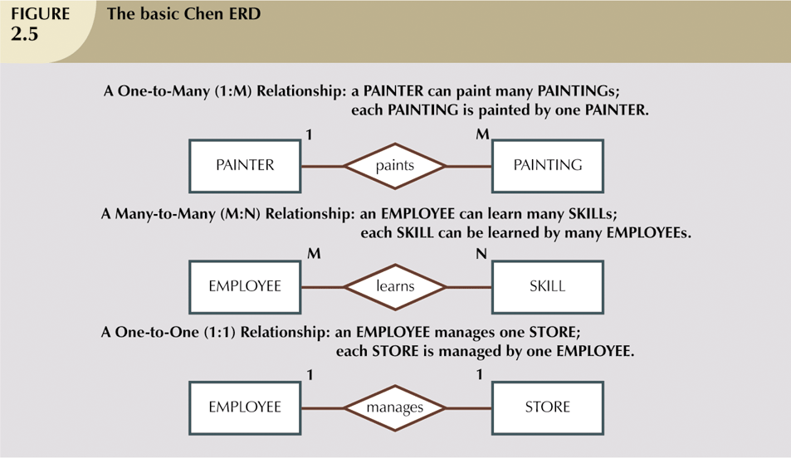

Crow’s Foot Notation
Crow’s foot notation is more commonly used for ERD’s today. Crow’s foot notation provides a visually descriptive way to show cardinality:


The Crow’s Foot ERD shown here presents the same entities and relationships as described by the Chen diagram.

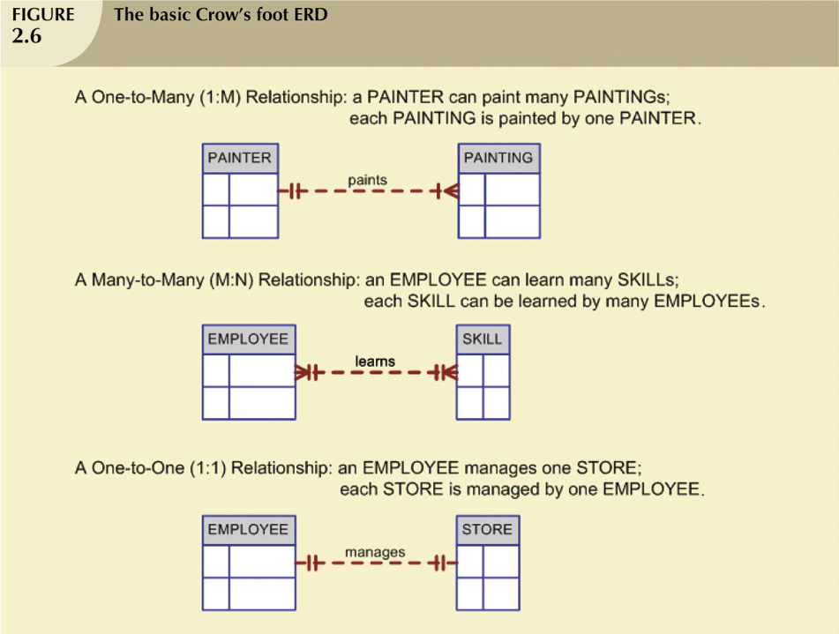

Microsoft Access ERD
This diagram shows two tables in a 1 to many relationship as viewed from Microsoft Access. The primary key is the CustomerID in the customer table and the foreign key linked to it is CustomerID in the tblOrder table. The cardinality is somewhat limited but Microsoft Access is a great prototyping tool for ERD’s when nothing else is available.

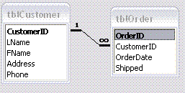

Data Abstraction
Data abstraction provides a way to model data so it can be viewed easily as required by different groups within an organization. In addition to ease of understanding the data model, data abstraction strives to reduce dependence between external views and software implementation and hardware levels.

Abstraction Levels
The following abstraction levels diagram shows four main levels of abstraction.
- External users who need to see different external schema to understand the entities and relationships for their departments.
- A conceptual view which contains the entire conceptual schema or conceptual model.
- An Internal Model which is constructed with the internal schema.
- The physical model describes the hardware / network / storage requirements for implementing the data model.
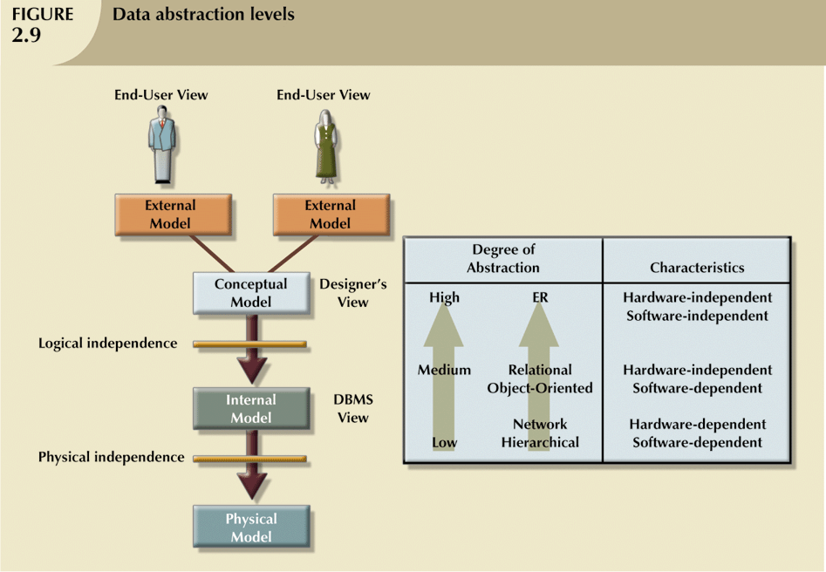

Here is the external model showing external views for different users. In this case the users might be the student registration department and the course scheduling department.
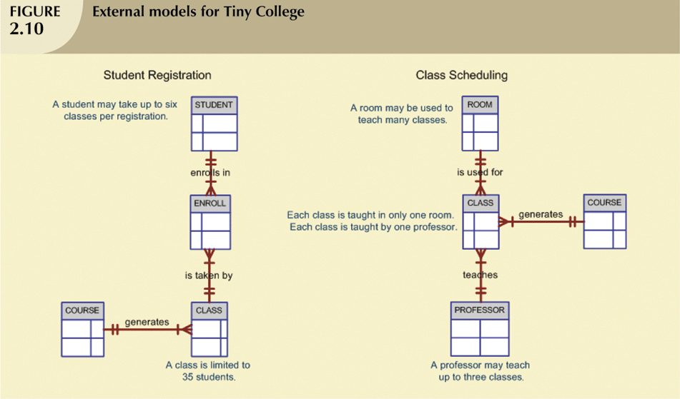

The conceptual model represents the entire entity relationship for the data model.

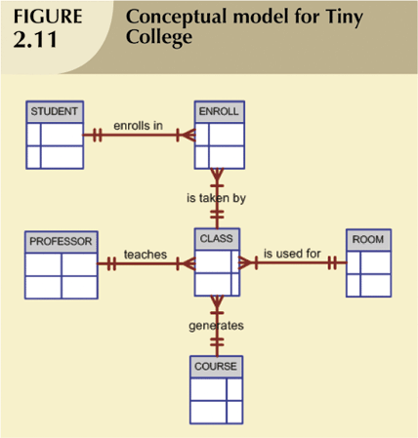

The internal model is the internal schema that is generated from the conceptual model. Even though implementations of data definition language and data manipulation language are similar for most mainstream databases, the syntax used for the internal model is dependant on the database platform chosen.
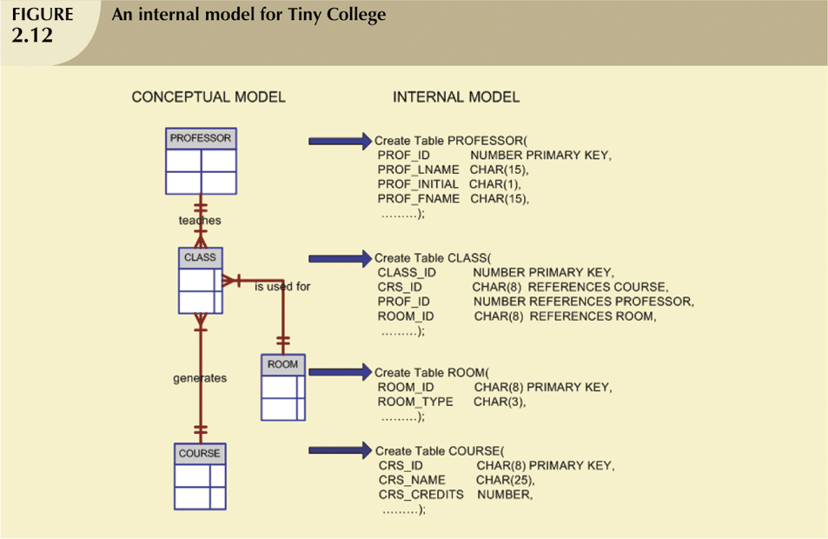

Data Modeling Independence
A good data model allows each layer of the model to remain independent the others as much as possible.

Logical independence
Logical independence exists when changes can be made to the internal model without affecting the external view or conceptual model. For example, the database may be ported to another rdbms and the schema may be modified but the external view of the data remains the same.

Physical Independence
Physical Independence exists when changes to the hardware and network do not affect the database schema.
The Relational Database Model
The relational database model is one of the more common methods used to enforce data integrity in the data model. Here are a set of guidelines that govern the design of a relational table.
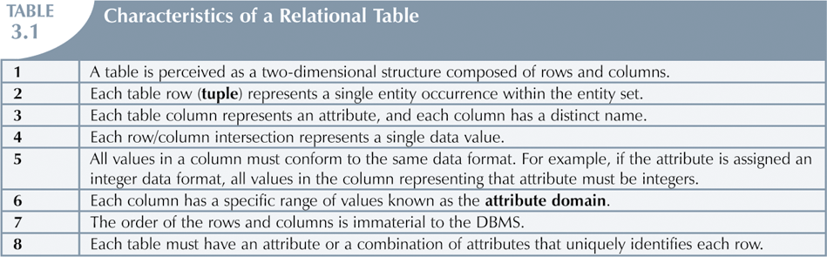

KEYS
Keys are attributes or combinations of attributes which define relations between tables.
- Candidate key
  - a simple or composite key that is unique and minimal- unique - no two rows in a table may have the same value at any time
  - minimal - every column must be necessary for uniqueness
- Composite key
  - Composed of more than one attribute
- Primary key
  - a candidate key selected by the designer to uniquely identify tuples in a table. It must not be null
- Secondary key
  - an attribute used strictly for retrieval purposes (can be composite). Ie. A person’s profile might use account # as the primary key. However, a person logging in to a website might use the secondary key such as their email address to retrieve their data.
- Alternate key
  - all other candidate keys not chosen as the primary key
- Foreign key
  - an attribute in one table that references the primary key of another table OR It can be null.
  - Both foreign and primary keys must be of the same data type

Integrity
Integrity refers to accuracy. When modeling the data it is important to implement a design that ensures the data is accurate during inserts, updates, and deletes.
Entity integrity
The primary key can not be null.

Referential integrity
FK contains a value that refers to an existing valid tuple (row) in another relation

NULL values
Null just means that no data has been entered for an attribute. Primary keys can not be NULL however you may have some fields where no data exists.

Relationships
- 1:M relationship
  - Relational modeling ideal
  - Should be the norm in any relational database design
- 1:1 relationship
  - Should be rare in any relational database design
- M:N relationships
  - Cannot be implemented as such in the relational model
  - M:N relationships can be changed into two 1:M relationships

Figure 3.21 shows a one to many relationship between course and class. Note how each course has only one unique instance and the primary key for the course is CRS_CODE. Also note that the class table can have many instances of the same course. The primary key for the class table is CLASS_CODE.


Avoiding M:N Relationships
M:N is a common abbreviation for a many to many relationship. These types of relationships should be avoided to preserve referential integrity. They pose a problem for duplication and also for viewing specific instances of a table. M:N relationships can be avoided with a bridge entity or link table

Solving the M:N Problem with a Composite Entity or Bridge Table or Link Table

A class can have many students. A student can have many classes. This relationship creates an M:N scenario which is not permitted for referential integrity.

We can solve this problem with a composite entity table or a link table. A linking table contains multiple occurrences of the foreign key values. Additional attributes may be assigned as needed. Figure 3.27 shows an Enrol table that is created to bridge the student with a class. The Enrol table can store classes for each student and their grades earned in each class.

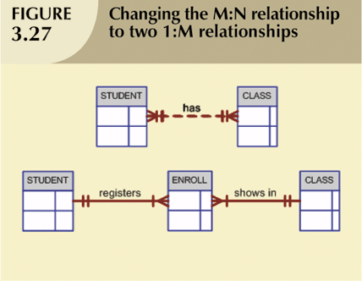

The final result from the entity relationship modeling should be a relational diagram. Here is the ERD (done in MS Access for the Tiny College)
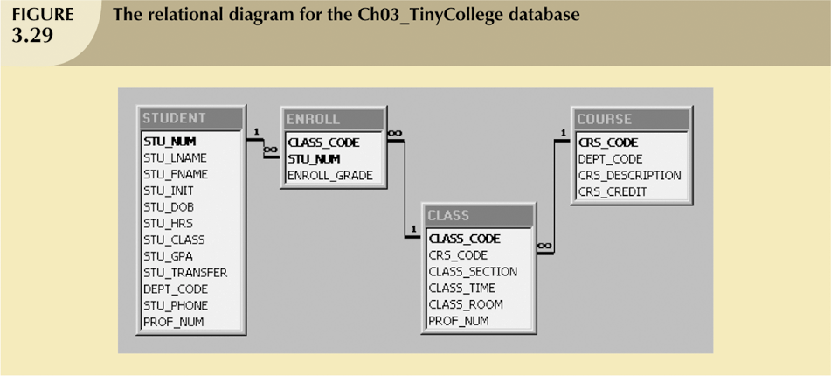

Class discussion 1: ERD
Draw the ERD using the following business rules:
- One region can be the location for many stores.
- Each store is located in only one region.
- Each store employs one or more employees.
- Each employee is employed by one store.
- A job – such as accountant or sales representative -- can be assigned to many employees.
- Each employee can have only one job assignment.
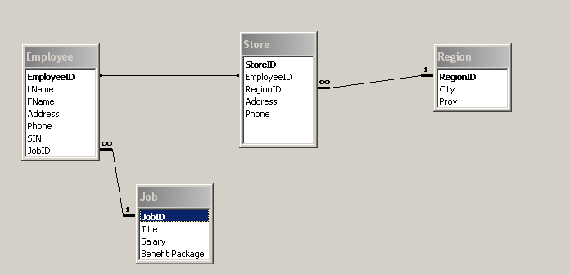

Class discussion 2: Business Rules

List the business rules associated with this diagram:
- Professor teaches many classes
- Professor advises many students
- Each class has only one professor
- Each student has only one professor
- These relationships are mandatory (at least one)
